**Question 1:** **What is the IP address and TCP port number used by the client computer (source) that is transferring the file to gaia.cs.umass.edu? To answer this question, it’s probably easiest to select an HTTP message and explore the details of the TCP packet used to carry this HTTP message, using the “details of the selected packet header window”**

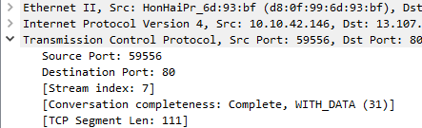**Answer:**

Hence, the IP address is 10.10.42.146 and the TCP port number is 59556.

**Question 2: What is the IP address of gaia.cs.umass.edu? On what port number is it sending and receiving TCP segments for this connection?**

**Answer:**

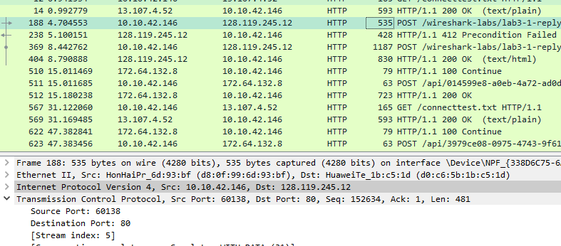

The IP address is 128.119.245.12 and the port number is 80.

**Question 3: What is the IP address and TCP port number used by your client computer (source) to transfer the file to gaia.cs.umass.edu?**



The IP address is 128.119.245.12 and the port number is 60138.

**Question 4: What is the sequence number of the TCP SYN segment that is used to initiate the TCP connection between the client computer and gaia.cs.umass.edu? What is it in the segment that identifies the segment as a SYN segment?**

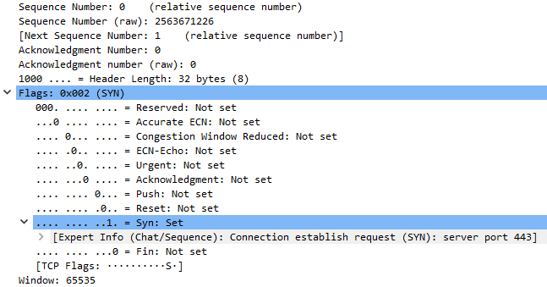

The sequence number of the TCP SYN segment is 0 since it is used to imitate the TCP connection between the client computer and gaia.cs.umass.edu.

**Question 5: What is the sequence number of the SYNACK segment sent by gaia.cs.umass.edu to the client computer in reply to the SYN? What is the value of the Acknowledgement field in the SYNACK segment? How did gaia.cs.umass.edu determine that value? What is it in the segment that identifies the segment as a SYNACK segment?**

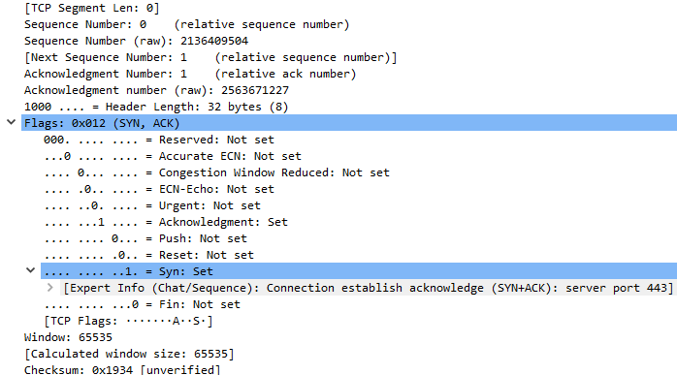

The sequence number of the SYNACK segment sent by gaia.cs.umass.edu to the client computer in reply to the SYN is 0. The value of the acknowledgement field in the SYNACK segment is 1.

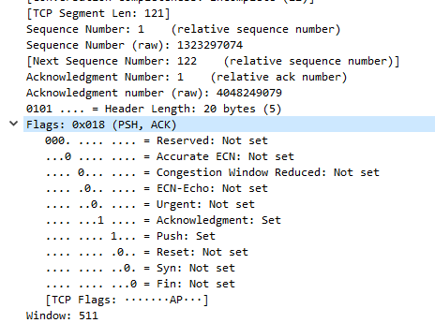**Question 6: What is the sequence number of the TCP segment containing the HTTP POST command? Note that in order to find the POST command, you’ll need to dig into the packet content field at the bottom of the Wireshark window, looking for a segment with a “POST” within its DATA field.**The segment No.6 contains the HTTP POST command, the sequence number of this segment is 1.

**Question 7: Consider the TCP segment containing the HTTP POST as the first segment in the TCP connection. What are the sequence numbers of the first six segments in the TCP connection (including the segment containing the HTTP POST)? At what time was each segment sent? When was the ACK for each segment received? Given the difference between when each TCP segment was sent, and when its acknowledgement was received, what is the RTT value for each of the six segments? What is the EstimatedRTT value (see Section 3.5.3, page 239 in text) after the receipt of each ACK? Assume that the value of the EstimatedRTT is equal to the measured RTT for the first segment, and then is computed using the EstimatedRTT equation on page 239 for all subsequent segments.**

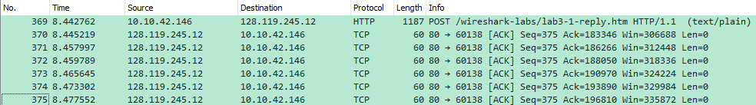

Graphs:

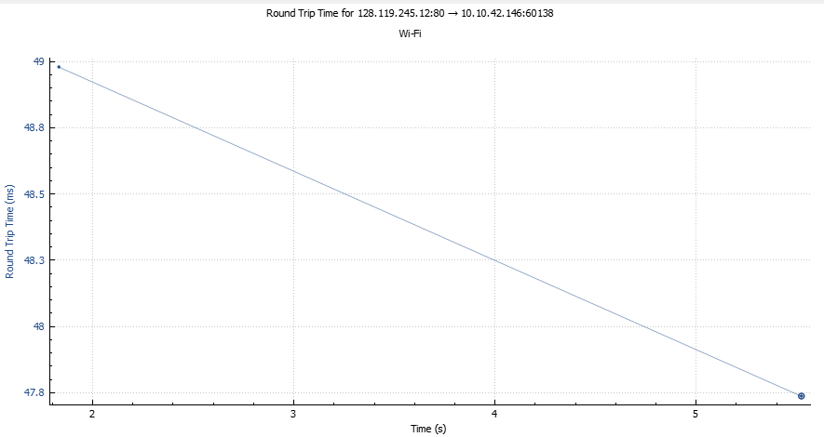

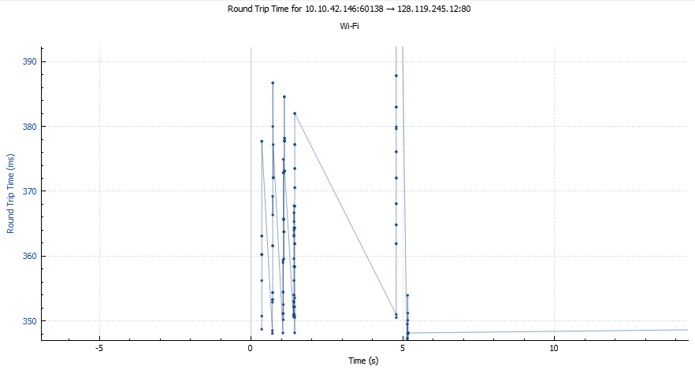

**Question 8: What is the length of each of the first six TCP segments?**

**Answers:**

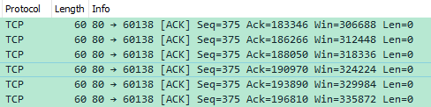

The length of first six TCP segments is 3600 bytes.

**Question 9: What is the minimum amount of available buffer space advertised at the received for the entire trace? Does the lack of receiver buffer space ever throttle the sender?**



The minimum amount of available buffer space advertised at the received for the entire trace is 2938 bytes.

**Question 10: Are there any retransmitted segments in the trace file? What did you check for (in the trace) in order to answer this question?**

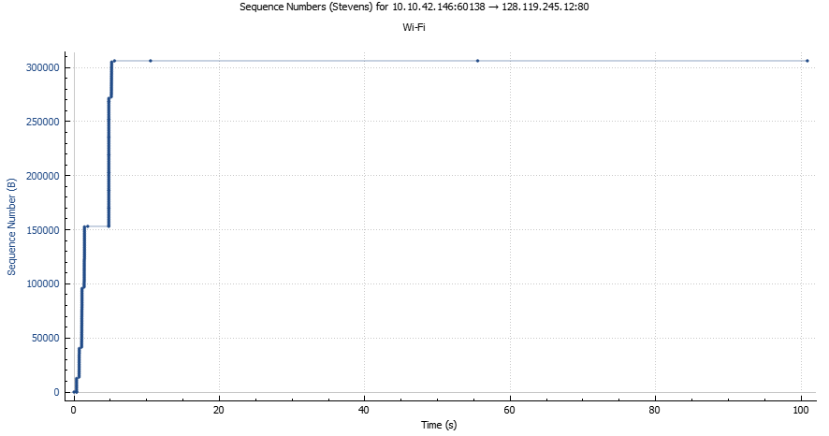

There is no retransmitted segments in the trace file since in the time sequence graph (stevens), all sequence numbers are monotonically increasing.

**Question 11: How much data does the receiver typically acknowledge in an ACK? Can you identify cases where the receiver is ACKing every other received segment.**

The difference between the acknowledged sequence numbers of two consecutive ACKs indicates the data received by the server between these two ACKs. The receiver is ACKing every other segment.



**Question 12: What is the throughput (bytes transferred per unit time) for the TCP connection? Explain how you calculated this value.**

The alice.txt on the hard drive is **155,648 bytes**, and the download time is:

= First TCP segment - last ACK

= 1.578736 ‐ 0.271257

= 1.307479 second.

Therefore, the throughput for the TCP connection is computed as:

= 155,648/1.307479

= **119044.35941227 bytes/second**

**Question 13:**

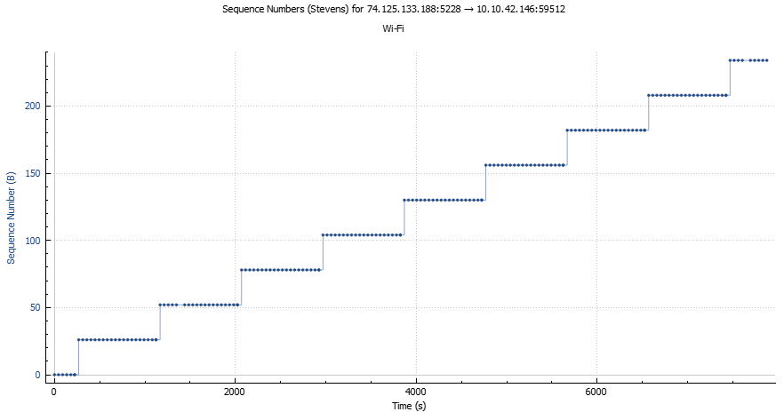

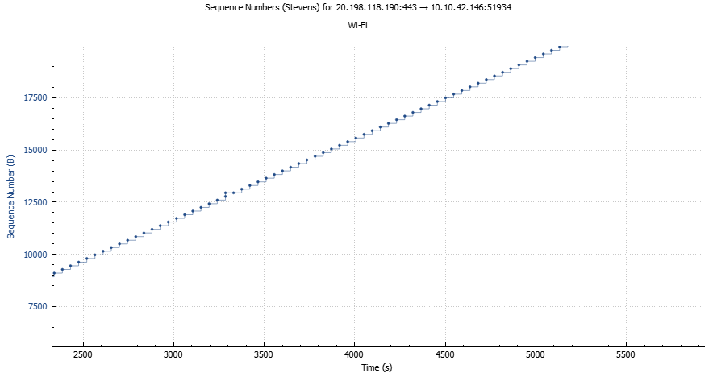

Let’s zoom in to find out where TCP’s slowstart phase begins and ends, and where congestion avoidance takes over.

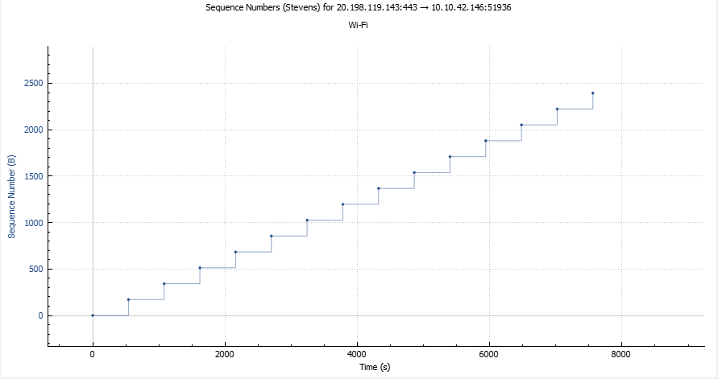

The slow start of the TCP seems to begins at 0 seconds.